

Department of Computer Science and Engineering

Course Code: CSE302

Course Title: Database Systems

Section: 01

Semester: Fall 23

**LAB 02**

**Submitted to:**

**Dr. Mohammad Rezwanul Huq**

Associate Professor

Department of Computer Science and Engineering

East West University

**Submitted by:**

**Name:** B M Shahria Alam

**ID:** 2021-3-60-016

**Date of submission:** 21th October, 2023.

**Lab Task # 01 (Schema Definition):**

**(i)**

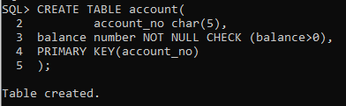

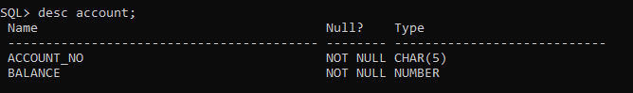

**(ii)**

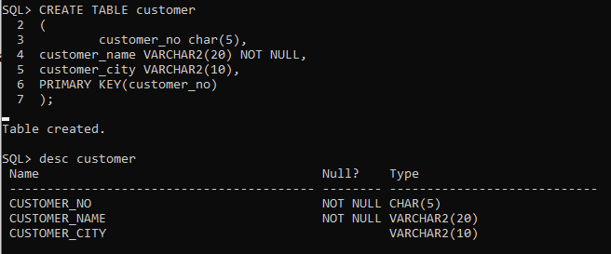

**(iii)**

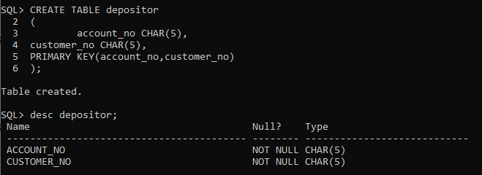

**Lab Task # 02 (Schema Modification):**

**(i)**

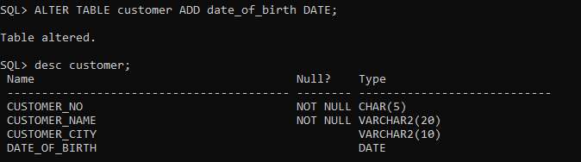

**(ii)**

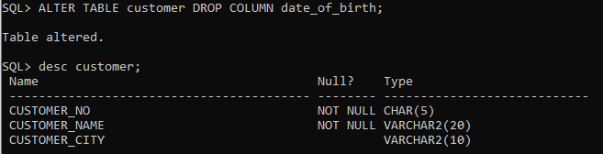

**(iii)**

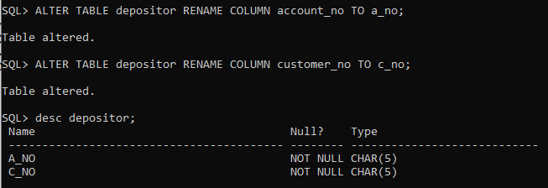

**(iv)**

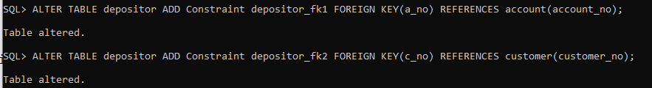

**Lab Task # 03 (Inserting Records into Tables):**

****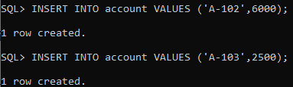

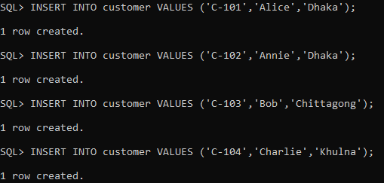

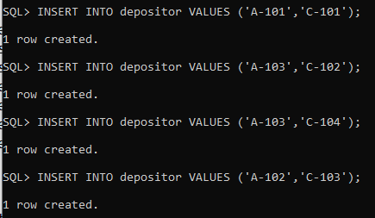

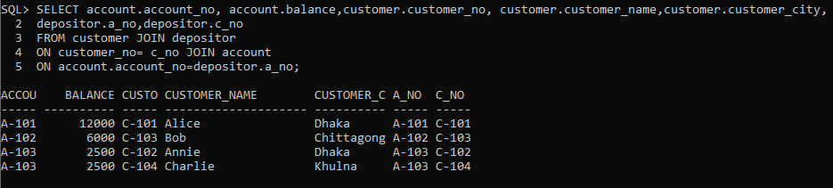

**Lab Task # 04 (Queries):**

**(i)**

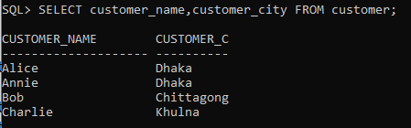

**(ii)**

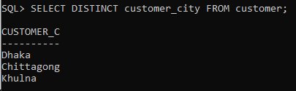

**(iii)**

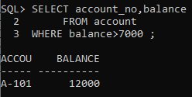

**(iv)**

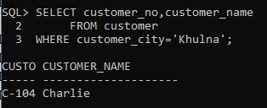

**(v)**

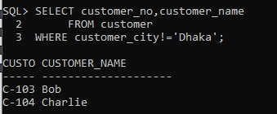

**(vi)**

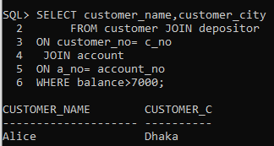

**(vii)**

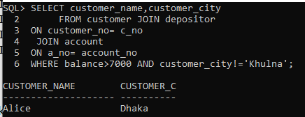

**(viii)**

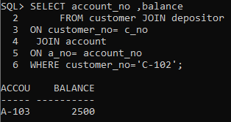

**(ix)**

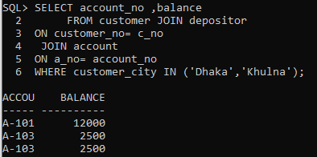

**(x)**

